CSC Operations – ESA Framework – Ground Segment Operational Configuration

APPROVAL

Title | CSC Operations – ESA Framework – Ground Segment Operational Configuration
Issue Number | ​1 | Revision Number | 2
Author | Coordination Desk Team | Date | 18/03/2024
Verified By | Coordination Desk T.O. | Date of Verification
Approved By | Head Copernicus Ground Segment Systems, H/EOP-GCY | Date of Approval
Approved By | Head Copernicus Ground Segment Services, H/EOP-GCS | Date of Approval
Authorized By | Head Copernicus Ground Segment and Data management Division, H/EOP-GC | Date of Authorization

CHANGE LOG
Reason for change | Issue Nr | Revision Number | Date
Updating Ground Segment Operational Configuration | 1 | 1 | 13/11/2023
Updating Ground Segment Operational Configuration | 1 | 2 | 18/03/2024

CHANGE RECORD
Issue Number | 1 | Revision Number | 1
Reason for change |  | Date | Pages | Paragraph(s)
Update list of Acronyms |  | 13/11/2023 | 7 | 1.2
Updated version of Master ICD document |  | 13/11/2023 | 9 | 1.3
Update description |  | 13/11/2023 | 8 | 2
Update CSC Configuration table:  - Renamed column “Operational IPF if applicable” in “Used Operational IPF if applicable”  - Renamed row “Systematic Production and Quality Control” in “Production Services”  - Renamed row “Data Preservation” in “LTA”  - Renamed row “X-band Acquisition” in “Acquisition”  - Delete row “Data Dissemination”  - Renamed row “CDSE” in “CDSE (Data Access & Traceability)”  - Delete row “Lv0 products Traceability service” |  | 13/11/2023 | 10 and following | 3
Updated Operational IPF |  | 13/11/2023 | 9 and following | 3
Updated Acquisition Stations Interface Point & Tailored ICD |  | 13/11/2023 | 13, 14 | 3
Added CDSE (Data Access & Traceability) service |  | 13/11/2023 | 14 | 3
Added S6 in the list of Satellites for POD |  | 13/11/2023 | 15 | 3
Updated version of ICD for S5P Consortium Acquisition |  | 13/11/2023 | 12 | 3
Update I&V matrix |  | 13/11/2023 | 11 | 4
Issue Number 1 |  | Revision Number | 2
Reason for change |  | Date | Pages | Paragraph
Correction acronym INUS in INS |  | 18/03/2024 | 7 | 1.2
Added KSE in the list of acronyms |  | 18/03/2024 | 7 | 1.2
Added MPIP in the list of acronyms |  | 18/03/2024 | 7 | 1.2
Updated version of Master ICD document  Update title of Master ICD document |  | 18/03/2024 | 8 | 1.3
Updated IPF version for S1A and S3B PSs (Serco) |  | 18/03/2024 | 12 | 3
Updated IPF version for S2A PS (ATOS) and S2B PS (CAPGEMINI) |  | 18/03/2024 | 12 | 3
Updated IPF version for S3A PS (ACRI) |  | 18/03/2024 | 12 | 3
Updated PDGS version for S5P PDGS (DLR) |  | 18/03/2024 | 12 | 3
Updated end of contracts for LTAs |  | 18/03/2024 | 13 | 3
Updated tailored SSC ICD |  | 18/03/2024 | 14 | 3
Detailed the information backup station and main station for each missions |  | 18/03/2024 | 14 | 3
Added mission S3 to SSC INUVIK ACQ |  | 18/03/2024 | 14 | 3
Add SSC Esrange ACQ |  | 18/03/2024 | 14 | 3
Update version of I&V matrix |  | 18/03/2024 | 17 | 4

DISTRIBUTION
Name/Organisational Unit

Table of Contents
1. Introduction 6
1.1. Purpose and Scope 6
1.2. Acronyms 6
1.3. Reference Documents 8
2. Context Overview 8
3. CSC Configuration 9
4. CSC INTERFACE MATRIX 16

- Introduction
  - Purpose and Scope
The scope of this document is to provide a ‘snapshot’ of the actual configuration of services belonging to Copernicus Space Component Ground Segment.
  - Acronyms
Acronym | Description
ADGS | Auxiliary Data Gathering Service
AIP | Archive Interface delivery Point
AUXIP | Auxiliary Interface Delivery Point
BEDC | Backup EDRS Data Centre
CADIP | CADU Interface Delivery Points Specification
CDSE | Copernicus Data Space Ecosystem
CSC | Copernicus Space Component
DD | Data Dissemination
DDP | Data Delivery Point
DLR | Deutsches Zentrum für Luft- und Raumfahrt - German Aerospace Center
EDIP | EDRS Interface delivery Point
EDRS | European Data Relay System
E2E | End-to-End
FOS | Flight Operations Service
ICD | Interface Control Document
INS | Inuvik Ground Station - SSC
INTA | Instituto Nacional de Técnica Aeroespacial - National Institute of Aerospace Technology
IPF | Instrument Processing Facility
KSAT | Kongsberg Satellite Services
KSE | Esrange Ground Segment
L0 | Level 0
L1 | Level 1
L2 | Level 2
LTA | Long Term Archive
MP | Mission Planning
MPC | Mission Performance Cluster
MPCIP | Mission Performance Cluster Service Interface Delivery Point
MPIP | Mission Planning Interface Point
MPS | Maspalomas Ground Station - INTA
MTI | Matera Ground Station – E-Geos
NEU | Neustrelitz Ground Station - DLR
PDGS | Payload Data Ground Segment (Sentinel)
PEDC | Primary EDRS Data Centre
POD | Precise Orbit Determination
SGS | Svalbard Ground Station - KSAT
SSC | Swedish Space Corporation
  - Reference Documents
[RD-1] CSC Operations ESA Framework Ground Segment Architecture ESA-EOPG-EOPGC-TN-7
[RD-2] ESA EO OPERATIONS FRAMEWORK (EOF)
CSC - GROUND SEGMENT MASTER ICD ESA-EOPG- EOPGC-IF-6 v 1.7
- Context Overview
As described in [RD-01], the Copernicus Space Component Ground Segment is in charge of:
- The Sentinels spacecraft monitoring and control, including execution of all platform activities and the commanding of the payload schedules.
- Implementing the Sentinels mission observation scenario in line with the satellite and ground resources and constraints.
- Acquiring the Sentinel instruments payload data, processing, archiving and making resulting users’ level data available.
- Monitoring and reporting on the operations performance.
- Maintaining the operational system under configuration management and control.
- Collecting external auxiliary data from Cal & Val external services.

The transformation of the Copernicus Ground Segment, implemented between 2019 and 2022, has enabled a significant modernisation and streamlining of the CSC Ground Segment interfaces and operations leading to a massive increase of performance, availability, reliability and flexibility, as resumed in the below picture:
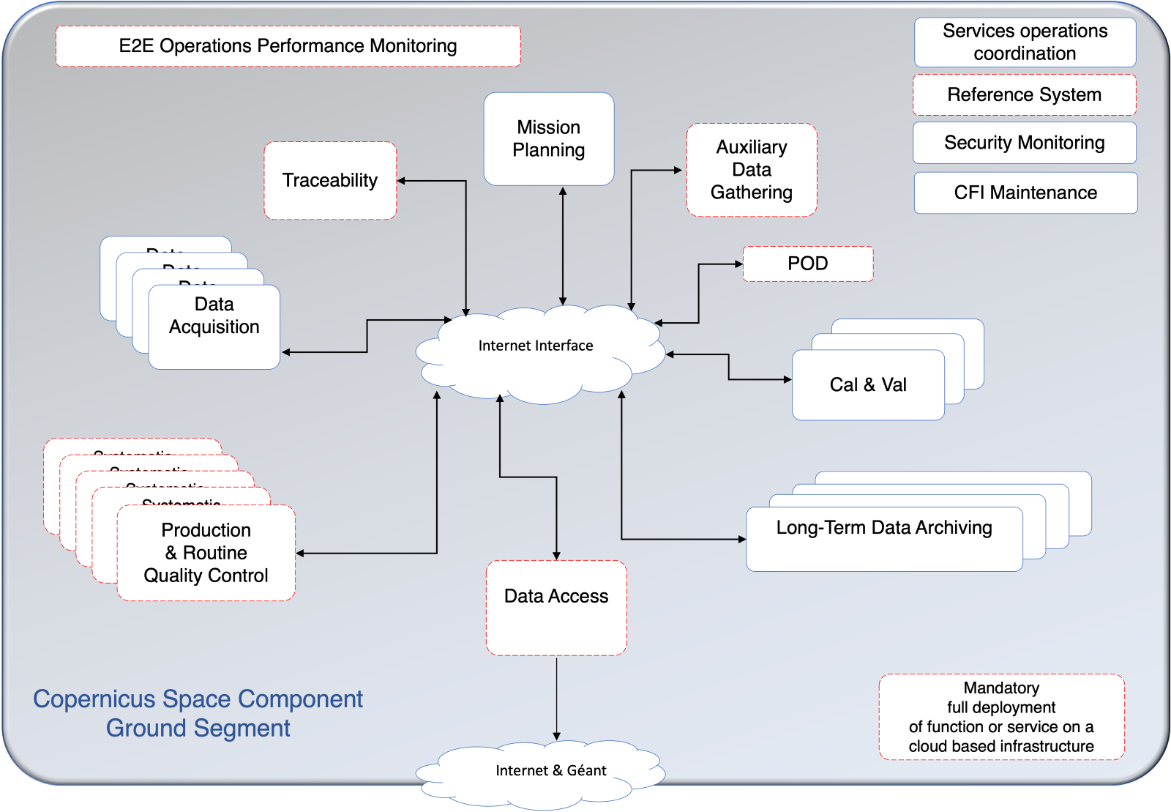
Figure 1: CSC Ground Segment General Architecture
The transformed CSC Ground Segment operations involve today a large number of industrial services and external interfaces, all together contributing to CSC data flow.

Each service runs autonomously based on inputs available at the interface entry point and provides output by its interface to the other CSC services. A coordination layer across the various services provides a comprehensive E2E view of all Sentinel missions managed by ESA.

- CSC Configuration
This section reports on the configuration of CSC Ground Segment Components.
The components can be grouped as follows:

- CSC INTERFACE MATRIX
This matrix provides the existing interfaces between the different services.
